4. HARDWARE AND SOFTWARE ARCHITECTURE
The KAPAS System Australian Lab Online Project’s Software and Hardware Architecture is presented using three tier architecture: Presentation Layer (Front End), Business Logic Layer (Backend) and Data Layer. The first table includes user roles which include Receptionist who manages appointments, Clinician who submits lab requests and view results, Laboratory staff that processes specimens and enter results, Administrator that manages users and settings and last but not the least, a patient who views and downloads lab results.
Hardware Architecture
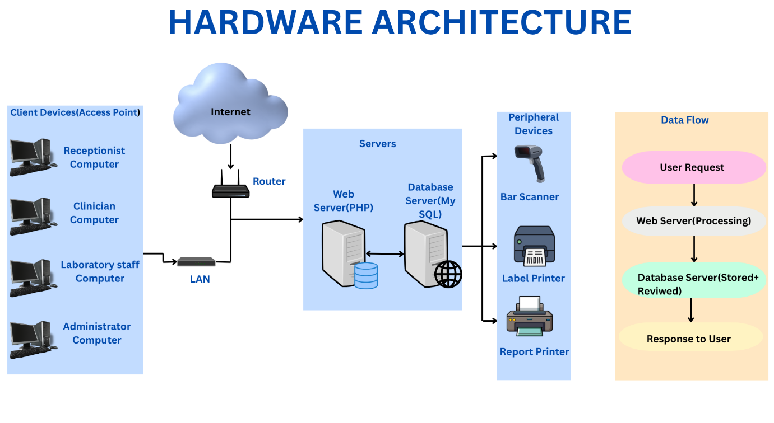
In the hardware architecture, the first table includes all the computers that are used by The KAPAS System user roles. The client devices are now connected to the online reporting system i.e, LAN. The router/ firewall controls internet traffic and shields the system from unwanted access. Likewise, when the router recognizes authorized users, it enables users to access the web based application remotely.
The second table is the servers table which includes two main servers which are Web server that uses PHP and Database server i.e., MySql .PHP web server helps to run the web application and communicates with the database server. Likewise, MySQL database server stores all the data from the system and helps to carry out SQL queries. Additionally, the system makes use of a number of hardware devices such as scanner for barcodes , printers for labels and printers for reports generated. The diagram on the right shows how data flow throughout the system.
Software Architecture
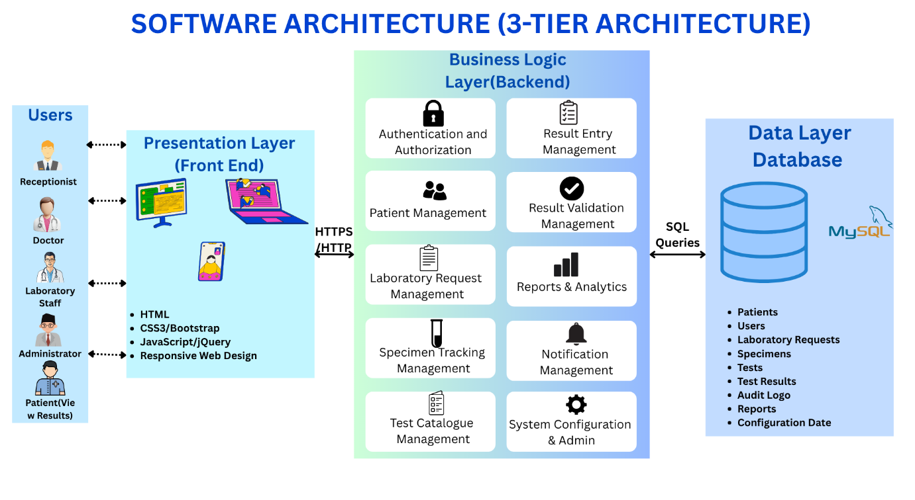
The presentation layer uses HTML5, CSS3, JavaScript, and responsive design to communicate with different roles through web browsers. Secure Logins, lab request submissions, report management and patient registrations.
The Business Logic Layer i.e., backend includes different core functions and processes the users request that consist of authentication and authorization, patient identity management, lab request management, specimen tracking management, test catalogue management, result entry management, report and analytics, notification management and system configuration and admin.
The backend then communicates with a data layer database using SQL queries in order to store, retrieve, update and delete data. The MySQL database is used to hold patient records, lab requests, user accounts, test catalogues, results, audit logs and configuration.

